TITLE IN bold CAPITAL LETTERS, Times new roman 11

Blank line

Presenting Authorª, Name Surnameª, Name Surname^{b} (Times New Roman 10)

Blank line
ªDepartment, Institute, Academy/University, Full postal address, ^{b}Department, Institute, Academy/University, Full postal address, Times New Roman 10, style italic
presenting.author@email.com

Blank line
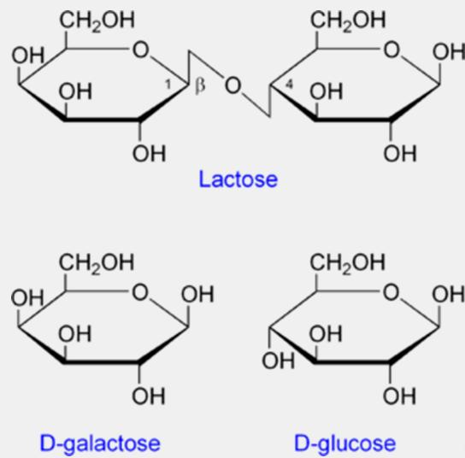
The abstracts should be sent as an e-mail attachment to chemsymp@savba.sk. For the correct form of the abstract follow requirements set out herein. The length of an abstract cannot exceed one page. Two pages are allowed for plenary lectures only. If your abstract contains tables or figures (Table 1 / Fig. 1), they have to be inserted in their final size as an external object (.tiff, .jpg, .jpeg or similar object formats) in the abstract. The “text wrap” option of the figures and tables should be “Square”.
The text, including tables and figures, has to be formatted on B5 paper size with margins 2.5 cm (on the top and bottom) and 2 cm (on left and on right), Font: Times New Roman 10, line spacing 1. References should be consecutively numbered within the text in [square brackets] and listed at the end of the abstract. Keeping the formatting (font, size, spacing, margins etc.) in the abstract according to this template is required.
The deadline for submitting the abstracts is May 31, 2024.

Fig. 1. Figure legend should be formatted in alignment left, under the figure, Times New Roman 9.

Blank line
You can insert your acknowledgement(s) here. Times New Roman 9, style italic

Blank line
References:
[1] Name all authors (three or more authors: first author's name followed by "et al."), Journal in Italic, year in bold letters, Vol. in Italic, pages. [2] Raab, M., et al., Carbohydr. Res., 2005, 340, 1051–1057.

